Alexandra Godown, David Guo, and Peter Giambrone
Pace University | Systems Analysis and Design
Crescent Barbershop
System design Final Project

Table of Contents
Introduction 2
Current Situation and Business Problems 2
Objectives 2
Scope 3
Benefits of Using an Online System 3
Project Plan 4
Analysis 4
System requirements (Functional + Non-Functional) 4
Brief Use Case Description 6
Use Case Diagram 7
Two Fully Developed Use Case Descriptions 8
Fully Developed Use Case Description: Create a customer account 9
Fully Developed Use Case Description: Book an appointment 10
Two Activity Diagrams for Use Case Descriptions 11
Activity Diagram: Create Customer Account 12
Activity Diagram: Book an appointment 13
DESIGN 14
User Interface for Crescent Barbershop 14
First Cut Domain Class Diagram 22
3NF Relational Database Schema 22
Two Sequence Diagrams 23
Sequence Diagram: Create A Customer Account 23
Sequence Diagram: Book an Appointment 24
Final Design Class Diagram 25

Introduction

Due to Covid-19, the dynamic of many businesses has completely shifted. Salons, barber shops, and spas- all involve person to person contact- a dangerous, and taboo topic during the pandemic. This paper is meant to explore remedy the problems that Crescent Barbershop is currently facing.

Current Situation and Business Problems

Crescent Barbershop in Long Island City, New York has been dealing with constant guideline changes, temporary shutdowns, and adaptations to the structure of their day-to-day business. A few of the challenges Crescent Barbershop has been facing: overcrowding due to social distancing guidelines, patrons wanting to pay with credit cards or digital payment (contactless), and confusion of appointment availability. These challenges are negatively impacting business and can be solved by creating an online system for both customers and Crescent Barbershop employees to benefit from.

The objectives listed below focus on clearing up current confusion and miscommunication between customers and employees of Crescent Barbershop. Creating an online system will allow customers the ability to go back and access information time and time again while feeling confident and content with their choice to go to Crescent Barbershop for their grooming services. This online system will establish Crescent Barbershop as a business keeping up with the times while putting client satisfaction and safety at the forefront.

Objectives

The objectives of this project are to sketch and design a system for Crescent Barbershop in Long Island City that:

- Allows customers to make an account and save their information and preferences in the system for convenience
- Has an online appointment booking system
- Shows average wait times for walk-ins
- Promotes contactless payment via Apple Pay or Google Play
- Grants users the opportunity to leave a review
- Lists all available services offered at the shop along with pricing
- Highlights the shop contact information

Scope

The purpose of the project is to introduce an online system for Crescent Barbershop during the pandemic that will positively impact their business now and continue to be beneficial in the future as well. Many consumers prefer to research, shop, and spend a majority of their time online, it is the prime timing for Crescent Barbershop and other companies to create or upgrade their online presence. The purpose of this project is to get a frame built for how the system should be structured as well as show executions of the core objectives.

Benefits of Using an Online System

- An account management system will save time for returning patrons in making appointments in the future.
- An online booking system will reduce the overcrowding issue the store has by booking an appointment on the website instead of waiting at the store, and save time for the patrons.
- Online payment will reduce the amount of contact with the barber and the patrons will have by using a Point of Service terminal that allows the users to pay via their smartphones, or smartwatches by using Apple Pay or Google Pay. While still having the option to pay via credit/debit card.
- A review system will attract potential patrons, and build trust in the sense that the barber gives out good haircuts.
- Showing the average wait times will allow customers to decide when they feel the best time to come in the shop would be.
- Having a full list of services and the prices will help the patrons save time instead of calling the store to get the information they need.
- A ‘call now’ button that connects customer to a Crescent Barbershop employee where the customer can make an appointment or ask any general operation questions.

Project Plan

Deliverable 1 | Deliverable  2 | Deliverable 3 | Deliverable 4 | Deliverable 5 | Deliverable 6
February 7th, 2021 | February 28th, 2021 | March 21st, 2021 | March 28th, 2021 | April 18th, 2021 | April 30th, 2021
Introduction | System Requirements | User Interface | Domain Class Diagram | Two Sequence Diagrams | Cover Page
Current Situation | Brief Use Case Diagram | Explanations | 3NF Relational Database Schema | Final Design Class Diagram | Table of Contents
Business Problems | Use Case Diagram |  |  |  | Introduction
Objectives | Two Fully Developed Use Case Diagrams |  |  |  | Project Plan
Scope | Two Activity Diagrams
Benefits of Using Online System

Analysis

System requirements (Functional + Non-Functional)

The requirements for this system are defined by FURPS+ which means they are categorized as functional or nonfunctional requirements. Functional requirements describe what the system needs to do to fulfill the needs of users. The nonfunctional requirements are about other system characteristics such as velocity, security, and documentation.

The functional requirements for Crescent Barbershop involve what a customer/actor and user/employee will need to do on the system to create accounts, book appointments, manage accounts, and more.

Functional Requirements
Create a customer account | The customer should be able to create an account and input their information and preferences which will then be saved in the system.
Book an appointment online | The actor picks which barber he would like to be seated with. Then, the actor picks what time he would like to be seated with the barber based on available time slots shown. Finally the actor indicates which services he would like.
Store appointments | Once an appointment is made, store the data and output a calendar of appointments for barbers to see. Updates cancellation or new appointments in real time.
Contactless Payment | With the system it must be able to allow contactless/online payment via Apple Pay, Google Pay, or entering credit/debit card information.
Wait Time | A system that allows an actor to see how long the average time it takes to get serviced by a barber at a given time.
Account  Management | The system must store individual customer account information securely while being able to add, remove, or edit this information.
Review System | The user can leave a review about the services they received from the barber. The user should be able to leave a review for a specific barber.

The nonfunctional requirements for this system involve mostly the volume of users and actors that will be accessing the system all at once, the system needs to be capable, secure, and accessible to make sure the system runs as expected.

Non-functional Requirements
Volume and Velocity | The system should reliably be able to handle any number of customers that make an appointment for services and peruse the site as wanted at any time.
Documentation for User | The User needs to understand how to operate the system such as,  updating their services, accepting and cancelling appointments, providing photos of their services etc.
Secure  Environment | The system has confidential user documentation in it, such as credit cards and personal data, and this information should be secured.
Accessibility | Guides and technical documentation, FAQs should be set up and be accessible so that every employee is able to use and understand who is coming to get a haircut and when.
Documentation for customers | There will be a help section for the customer/actor in case they do not know how to create an account, book an appointment, or choose what kind of services they want, in the form of a video.
Supportability /  Installation /  Usability /  Portability | The system should be easy to understand and begin making an appointment. It should be easy to install on any operating system.

Brief Use Case Description

Brief use case descriptions are textual models that list and explain the processing details for a use case. Brief descriptions give enough detail for simple use cases and are ideal for small systems being developed that are well understood. The brief use case descriptions listed for Crescent Barbershop are fundamental to the system and explain the needs the system will need to satisfy in simple detail.

Use Case | Brief Use Case Description
Create customer Account | Customers/actors create an online account listing customer information such as name, phone number, and email address with their service preferences.
Look up Customer | Employees can look up customer names to see what their preferences are as well as appointment information.
Book an appointment | Allow actor to choose an available time slot and select which services they want to have done.
Edit an existing appointment | Actor can make any changes needed such as time, style, services, etc. Notify the barber of the changes.
Delete an existing appointment | Cancel an appointment and notify the barber. Update change on the schedule.
Add new barbers | User can add new barbers to the system
Delete barbers | User can remove barbers from the system
Add new services | User can add new offered services to system
Delete existing services | User can remove services from the system
Update general website information | Allow users to update website information such as descriptions, store information and hours, graphics, and more.
Make an online/ contactless payment | Allow customers/actors to make a payment with payment information saved in their customer profile or allow on the spot entry of payment information.
Allow actors to create a review | Actors can leave a review on the services they received.

Use Case Diagram

A use case diagram is the Unified Modelling Language (UML) model that illustrates the relationship between use cases and actors in the system. In the case of Crescent Barbershop, we have customers and employees. Employees have full access to edit and add information to the website, make changes to appointments and barber employment status, etc.. There are only a few barbers working in the shop and the system is small, so each is allowed full access to the system to make necessary changes meaning there is no management intermediary or role.

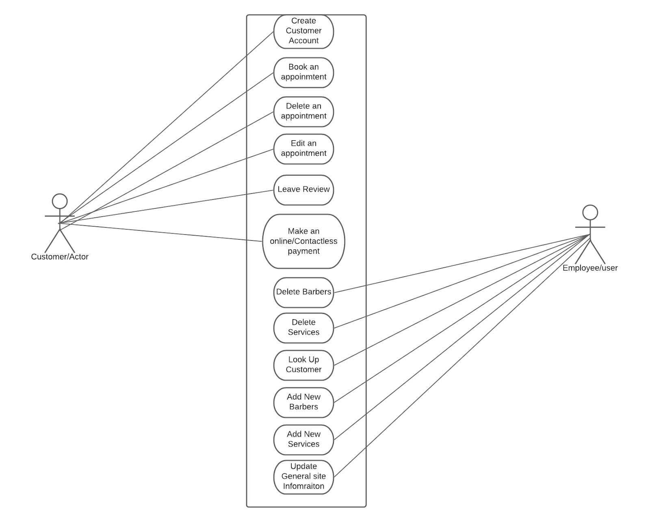

Two Fully Developed Use Case Descriptions

Fully developed use case descriptions are the most formal method used to document a use case. Creating a fully developed use case description pushes software developers to fully understand the business processes and the needs of users that are associated with them to a great depth. Each compartment of the use case plays an integral role in understanding its entirety. The use cases fully developed for Crescent Barbershop are Create a customer account and Book an appointment. These use cases were chosen due to the role they have in the overall system in terms of business and account management.

Fully Developed Use Case Description: Create a customer account

Use case name: | Create a customer account
Scenario: | Create a customer account/profile online with Crescent Barbershop.
Triggering event: | New customer wants to make an online account.
Brief description: | User enters new customer account data, which includes name, phone number, email, and option to list credit/debit card information to make ease of payment. The system creates a record of the customer and stores the data while assigning an customer account number.
Actors: | Customer
Related use cases: | Book an appointment, Make an online/contactless payment
Stakeholders: | Customer, Crescent Barbershop, Crescent Barbershop Management
Preconditions: | A customer account database must be available.  Customers must have a valid phone number.
Postconditions: | Customer account must be created and  successfully saved.  If payment method information is entered, it must be valid.
Flow of activities: | Actor | System
Flow of activities: | 1. Customers indicate a desire to create an account and enter their personal information.  2. Click to submit Information. | 1.1. System creates a new customer account with its own account number.  1.2. System stores all of the entered information into the new customer account.  1.3. Associate name, phone number, and email address with fields in the database.
Exception conditions: | 1.1. Account data is not completely stored  2.1. Phone number is invalid from customer account

Fully Developed Use Case Description: Book an appointment

Use case name: | Book an appointment
Scenario: | A customer/actor would like to book a service with the Crescent Barbershop
Triggering event: | The customer requests an appointment with the Crescent Barbershop.
Brief description: | The actor picks which barber he would like to be seated with. Then, the actor picks what time he would like to be seated with the barber based on available time slots shown. Finally the actor indicates which services he would like via dropdown menu.
Actors: | Customer, Employee (Barber)
Related use cases: | Create a customer account, payment
Stakeholders: | Customer, Crescent Barbershop, Crescent Barber
Preconditions: | Customer must have an account in the database.
Postconditions: | Customer will have received his services.  Valid payment has been given.
Flow of activities: | Actor | System
Flow of activities: | 1. Actor clicks on make an appointment.  2. Actor chooses name of desired barber  3. Choose an available time slot from display.  4. Actor lists desired services and submits. | 1.1. Creates appointment record  1.2 Prompts actor to choose name of desired barber.  2.1 System confirms barber and displays available time slots  3.1 Time slot confirmed with system automatically.  3.2 Prompts actor to list desired services.  4.1 Appointment details confirmed.  4.2 User is redirected to the payment method page
Exception conditions: | 3. No appointments are available with barber, will show other barber availability.

Two Activity Diagrams for Use Case Descriptions

Activity diagrams describe the activities that occur between the system and user/actor as well as the sequence flow of these activities, it essentially diagrams how the system and user interact to accomplish a desired task. For Crescent Barbershop, the two activity diagrams are highlighting Create customer account and Book an appointment, to keep in line with the choices for the fully developed use case descriptions.

Activity Diagram: Create Customer Account
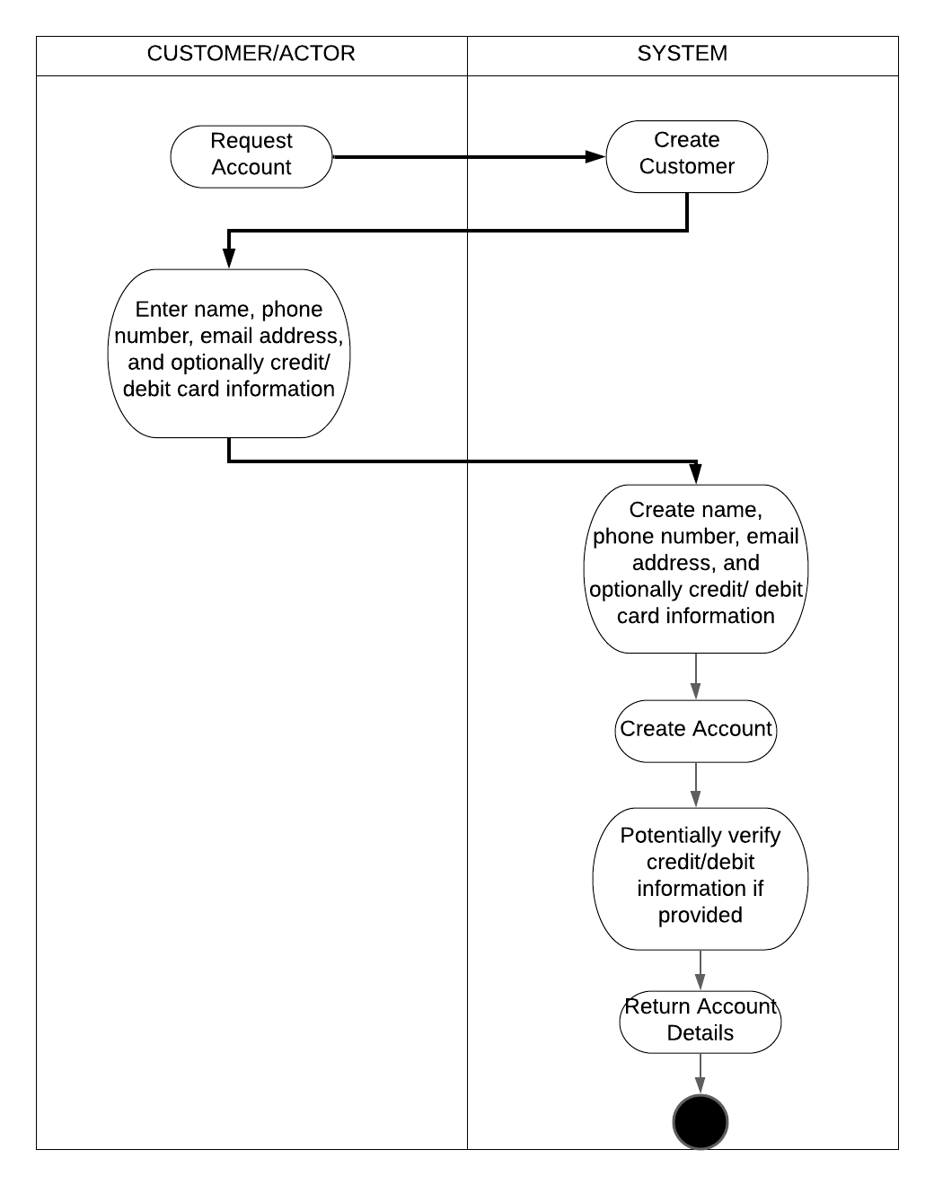

Activity Diagram: Book an appointment
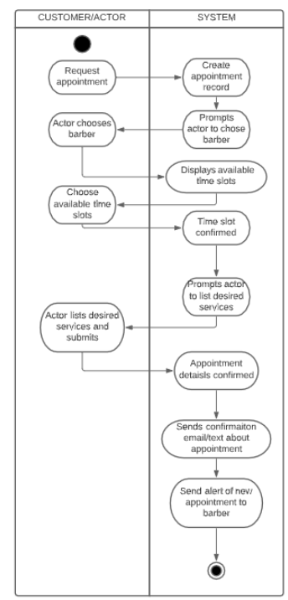

DESIGN

User Interface for Crescent Barbershop

Here is our User Interface of the mobile application, Version 1.0.

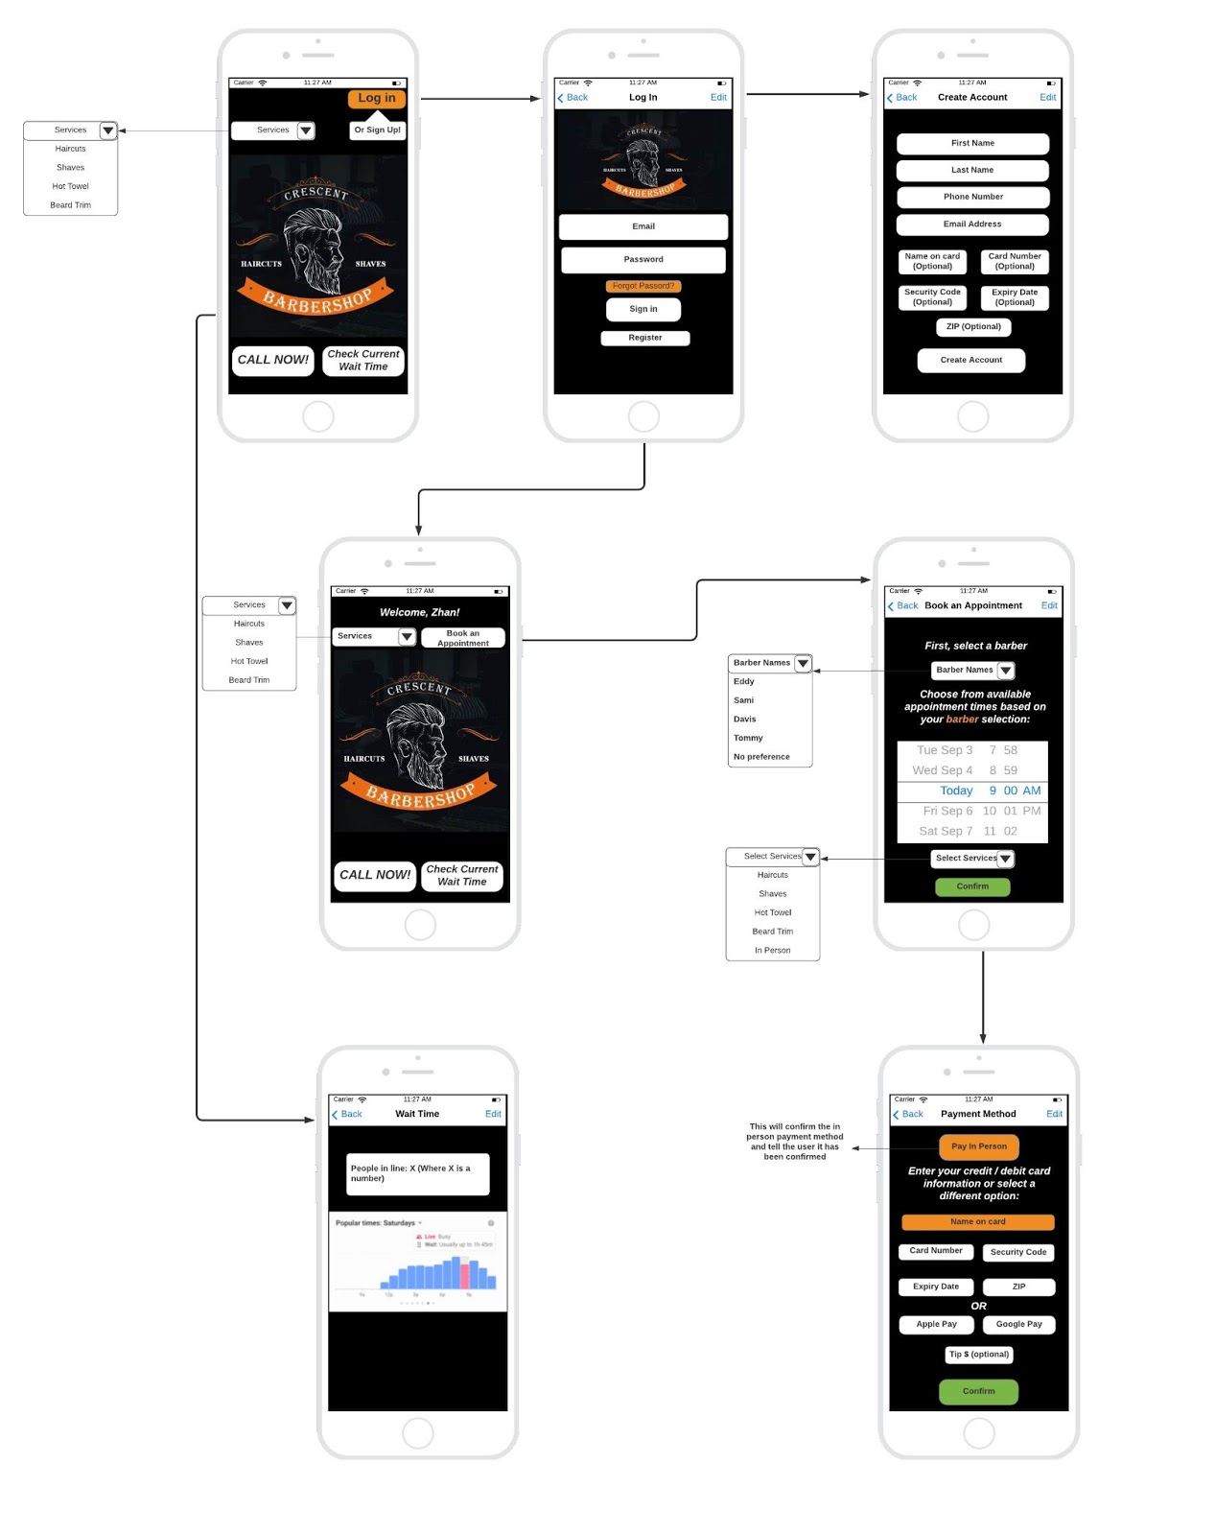

This is an overview of our entire User Interface which we will then break down by section.

Webpage names are italicized and “buttons” are in bold and quotation marks.

This is the homepage of our app where actors can see what “Services” are listed via drop down menu. Using a drop down menu allows for actors to not be bombarded by information that they may not want. With the drop down design, if an actor is interested in types of services provided, simply touch the down arrow and a list will populate. Also on the homepage is a “Log In” button with a tool tip of stating users can sign up for an account using the same button. This was an effort to make the design sleek and not crowd the home screen. Towards the bottom left of the homepage is a “Call Now” button which dials Crescent Barbershop’s phone number with just a click if actors have any questions. The final button on the homepage is “Check Current Wait Time” which will bring users to another screen showing the wait time status of Crescent Barbershop for walk-in clientele. This function is primarily for those who do not have an appointment and are more spontaneous with their scheduling.

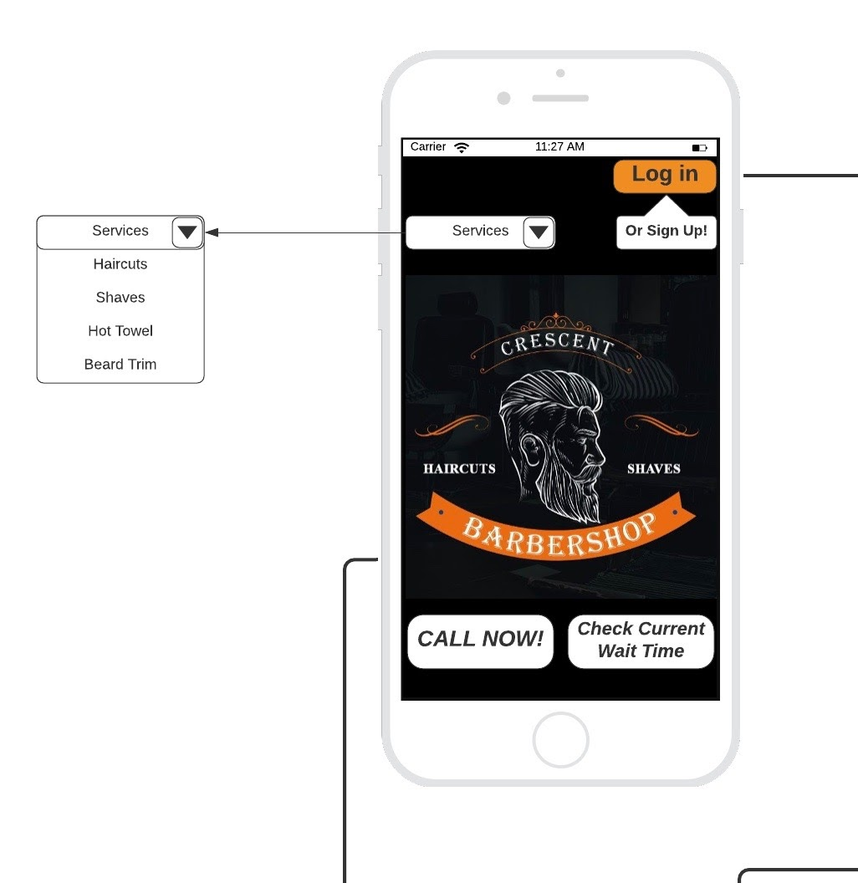 Homepage
Once the actor touches login from the homepage, they are redirected to the log in page and are prompted to enter their email and password. If the actor forgets their password, the actor can touch “Forgot Password” and would be able to send their information to their email to regain access to their Crescent Barbershop account. If the actor does not already have an account, the actor can touch the “Register” button and will be redirected to the create account page.

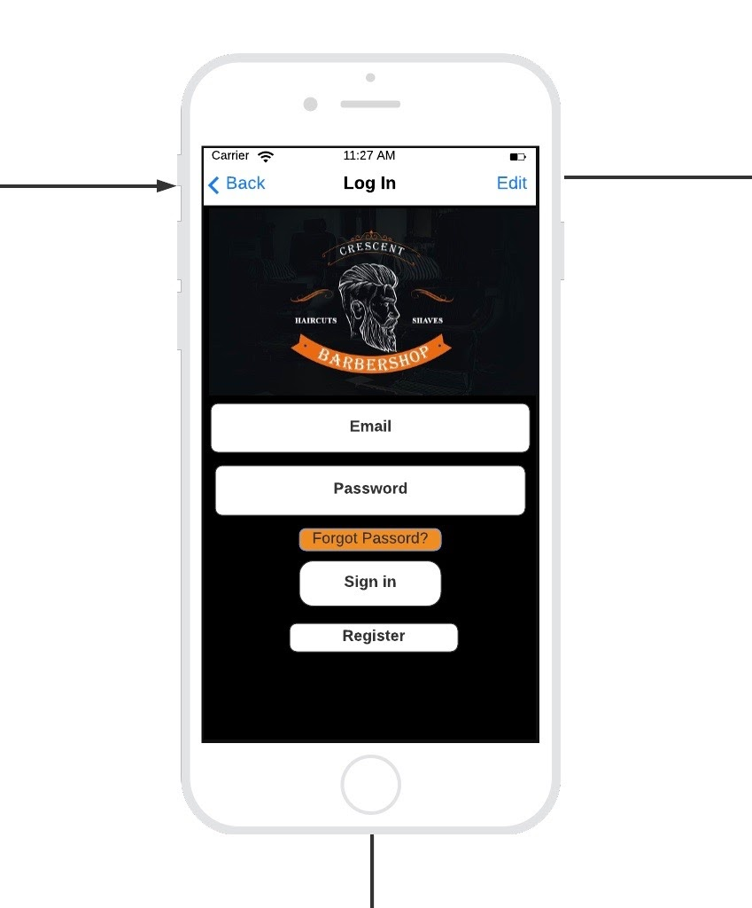Log in page

Once on the create account page, the actor enters their first name, last name, phone number, and email address. Optionally, they can enter their credit/debit card information to keep on file for later payment. Once the actor enters their information, they need to select “Create Account” and will then be redirected to the welcome page.

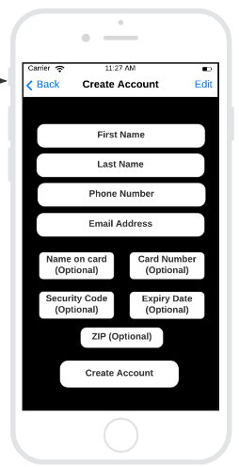Create Account page

The welcome page is where actors are brought to after signing in or creating an account. This page highlights the actor’s name at the top of the screen as well as a drop down services menu, similar to the homepage. There is also a “Book an Appointment” button which will bring actors to the book an appointment page. On the bottom of the welcome page, there are “Call Now” and “Check Current Wait Time” buttons which serve the same purpose as aforementioned.

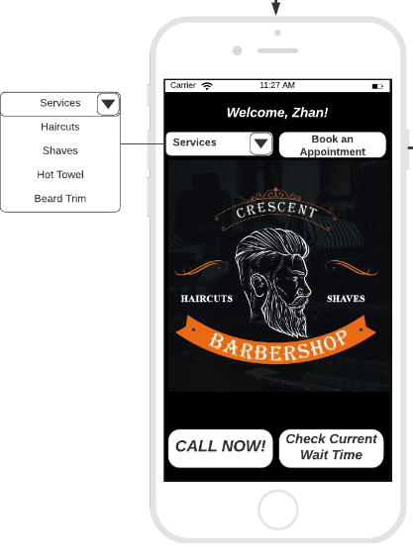Welcome page

When an Actor clicks on “Check Current Wait Time” another screen will appear with information and a chart on how busy the store is, and how many people are waiting for their turn if they chose “Walk-In.”

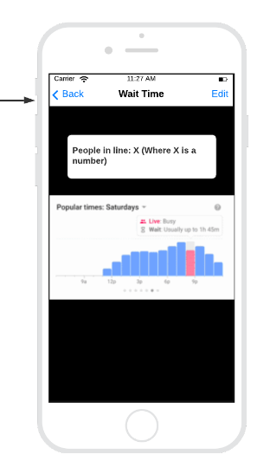Wait Time page

The book an appointment page is where actors are redirected from the welcome page once they are ready to make an appointment with Crescent Barbershop. At the top of the page, the actor is prompted to first pick the barber they would like the service of using a drop down menu with a list of barber names titled “Barber Names”. Once a barber is chosen, a list of available times and days will appear. The actor is then prompted to choose from available appointment times based on their barber selection. At the bottom of the page is a drop down menu that will show the actor a list of possible services that the barbershop can provide. Finally, the user must click the green “Confirm” button to lock in their appointment information.

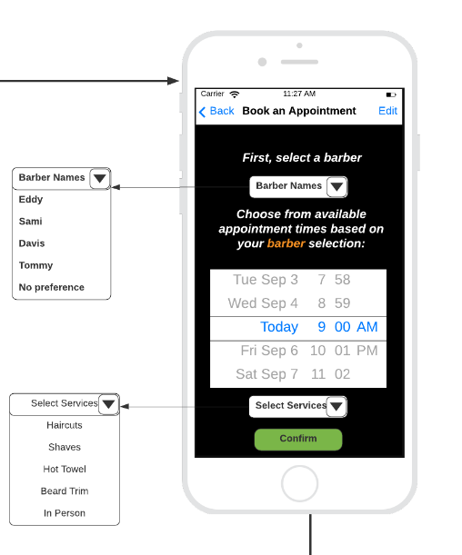
Book an Appointment page
The actor is then directed to the payment method page (if they have not yet entered it at the create account page), where the actor can either pay with credit card, Apple/Google Pay, or pay in person. There is a tip check-box, where the actor can choose to either tip right now, or tip in person. Once this is complete, the actor must press “Confirm” which will send them a text or email, verifying that the appointment has been made. The “pay in person” button will confirm the in person payment and alert the user.
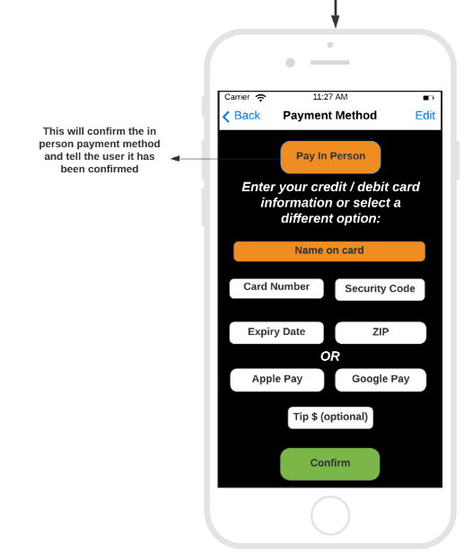
Payment Method Page

First Cut Domain Class Diagram

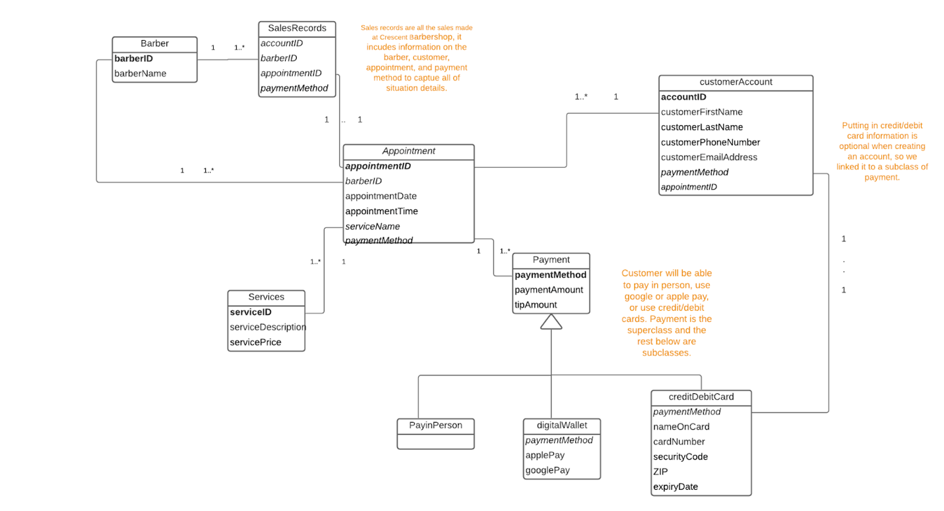

3NF Relational Database Schema

Create Account
accountID | customerFirstName | customerLastName | customerPhoneNumber | paymentD | AppointmentID

Appointment
appointmentID | barberID | serviceName | paymentMethod | appointmentDate/Time

SalesRecord
accountID | barberID | appointmentID | paymentMethod

Barber
BarberID | barberName

Services
serviceID | serviceDescription | servicePrice

Payment
paymentMethod | paymentAmount | tipAmount

digitalWallet
paymentMethod | applePay | googlePay

creditDebitCard
paymentMethod | nameOnCard | cardNumber | securityCode | ZIP | expiry date

PayInPerson

Two Sequence Diagrams

Sequence Diagram: Create A Customer Account

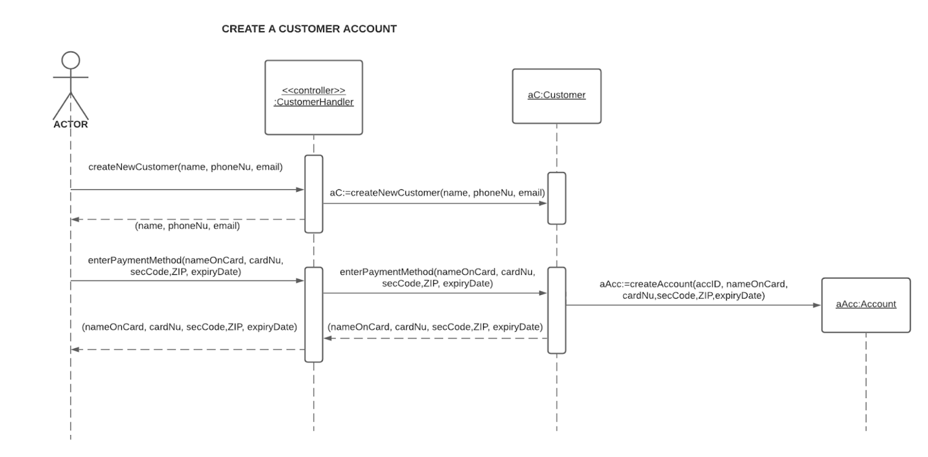

Sequence Diagram: Book an Appointment

Customer indicates the desire to create a new appointment and then an appointment ID is created by the system. The actor is then prompted to select a barber to complete the desired services and then the available appointment times appear. The actor selects an appointment time and then lists the services they wish to get done at Crescent Barbershop. The services are brought all the way through the system to the payment section because the service price will need to be paid through the payment system. After the services are chosen, the actor will need to select a payment method. After all of these actions are complete, the appointment is confirmed by the system and a confirmation email/text is sent to the actor.

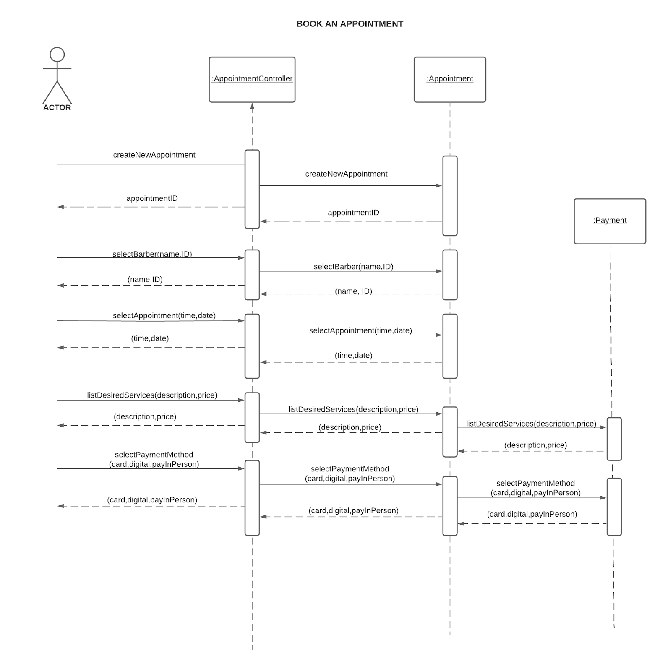

Final Design Class Diagram

The final design class diagram lists all of the classes from the domain class diagram and shows the attributes and methods of each class.

